# Dumps aca security

Which of the following statements are not true about ‘Server Guard’ remote logon detection functionality

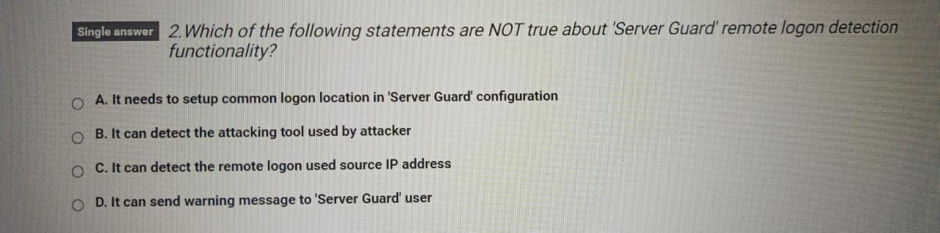

A

In windows os users can set software update configuration in various modes. Which software update configuration listed here is not supported at all

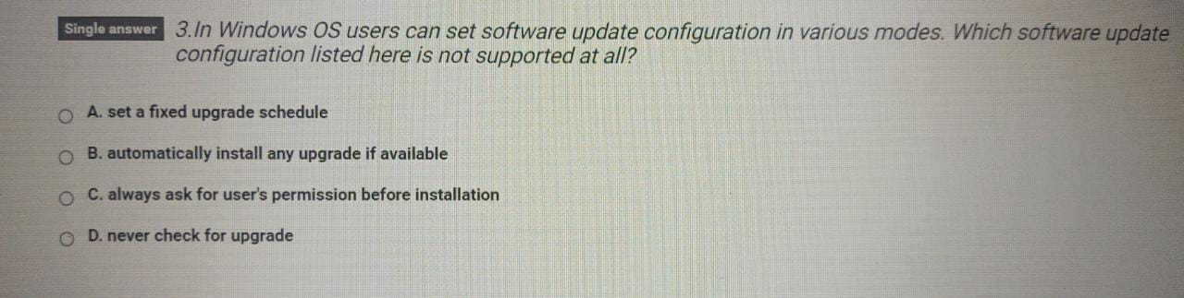

D

Please list the correct order of the following 4 steps to enable a WAF Service :

1. Upload https ca and private key
2. Add the domain name that needs to be protected
3. Select the original ip address
4. Add cname dns record

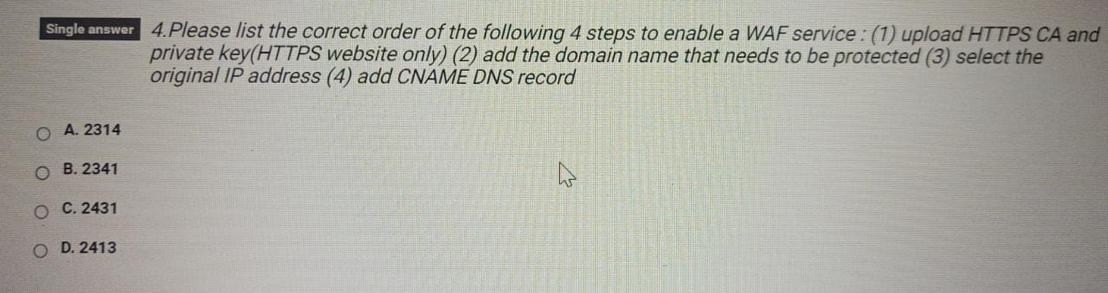

2 Add domain name -> 3 Input your service domain, Protocol type: HTTP, Server address: IP, input your Web server's Public IP or SLB's Public IP here. Any layer 7 proxy: Yes. -> 4 cname -> upload https ca and key

Which of the following benefit cannot be provided by server guard

b

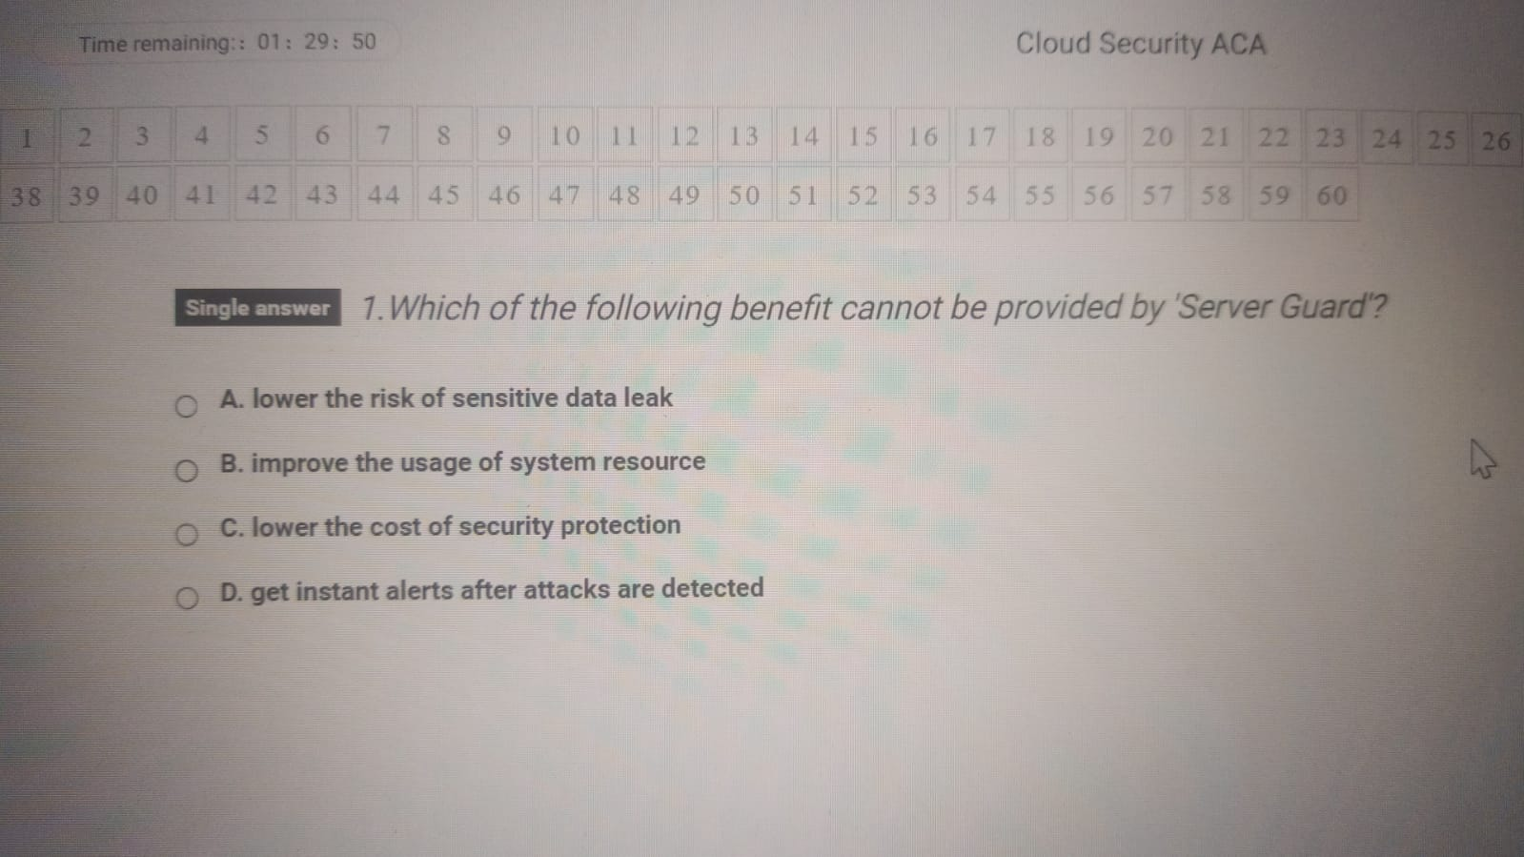

Which of the following statements are not true about server guard remote logon detection functionalityA



In windows os users can set software update configuration in various modes. Which software update configuration listed here is not supported at all



D

Please list the correct order



A

Which of the following functions can be provided by alibaba cloud server guard productabc

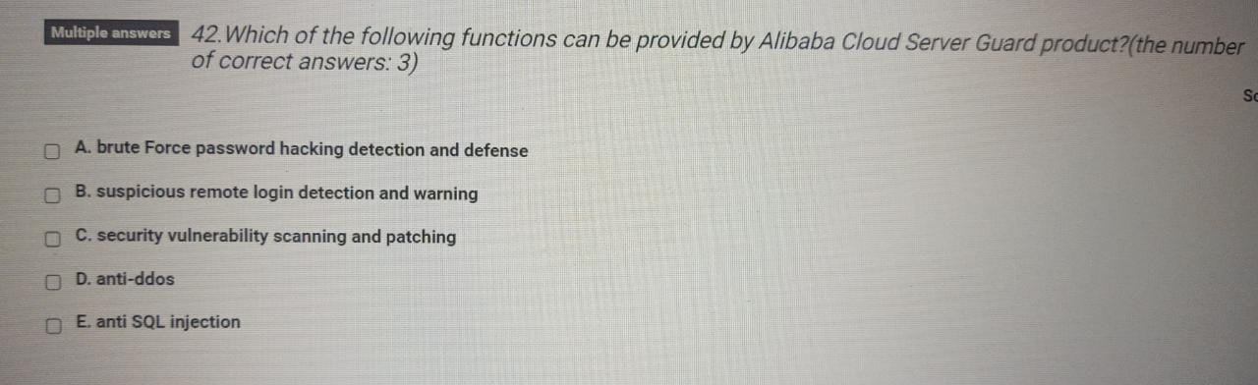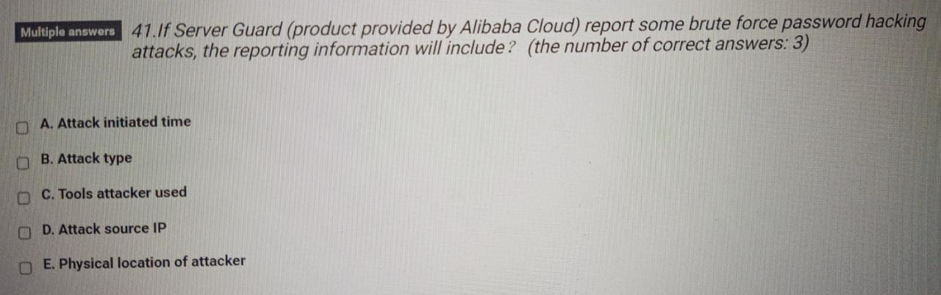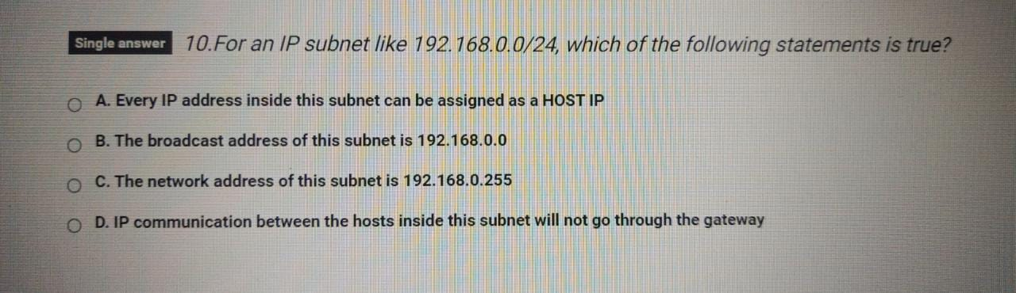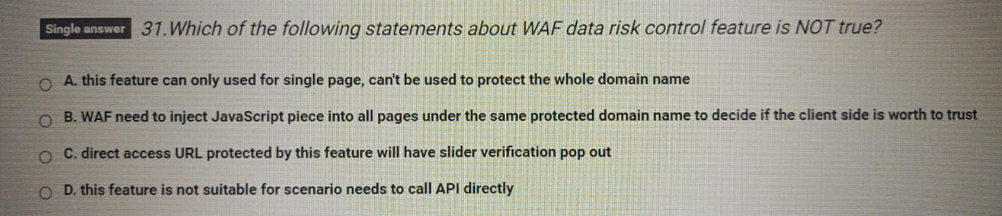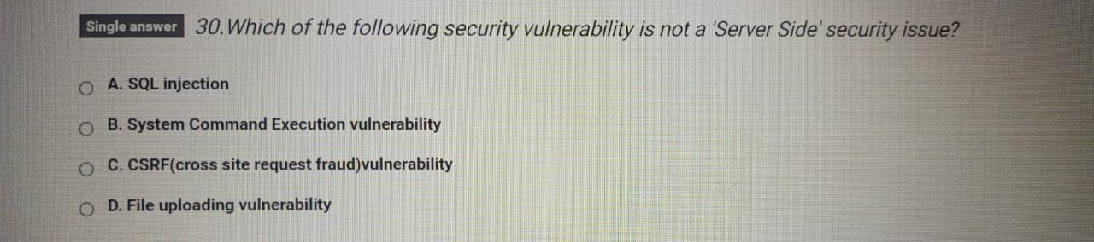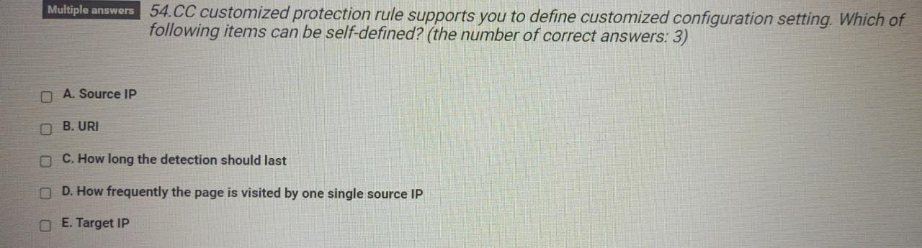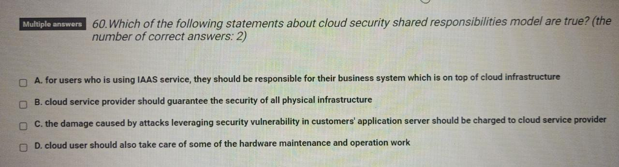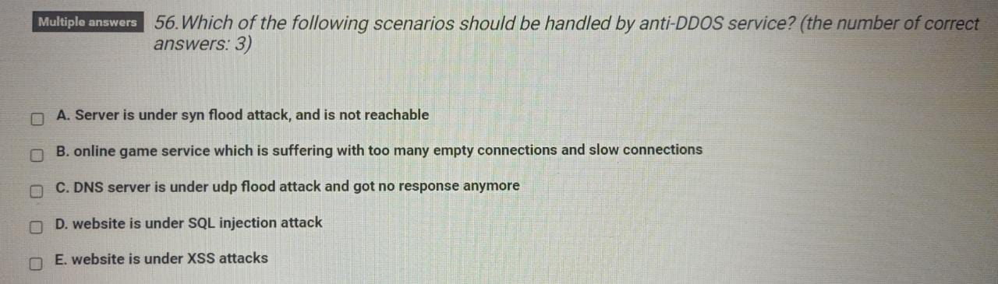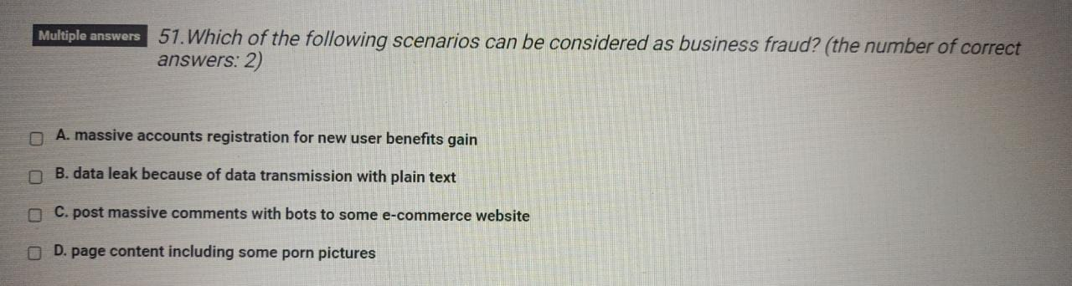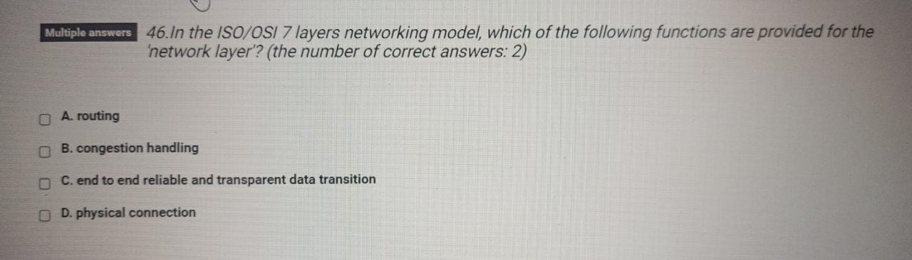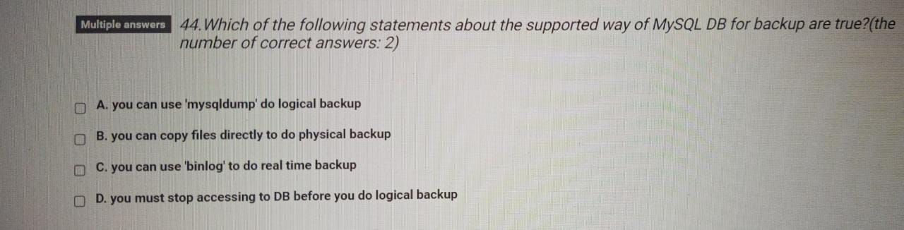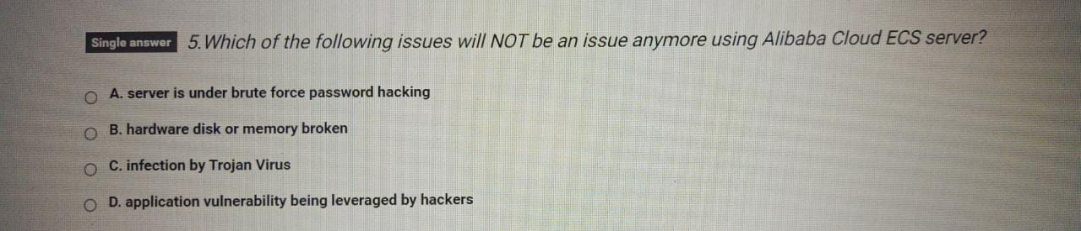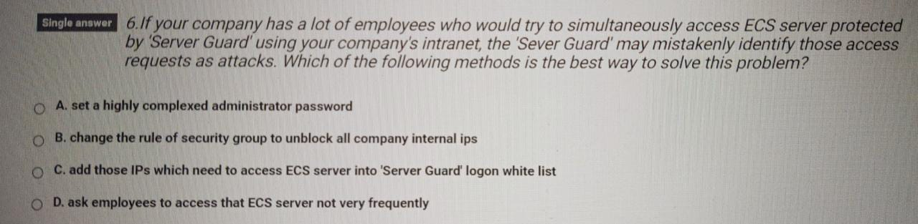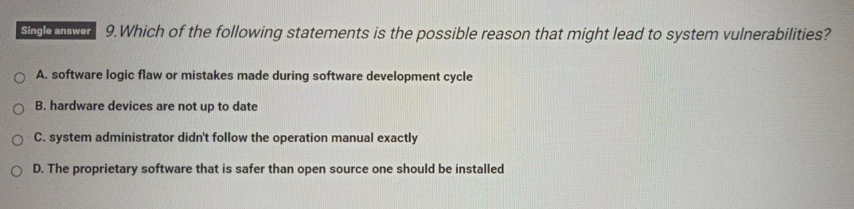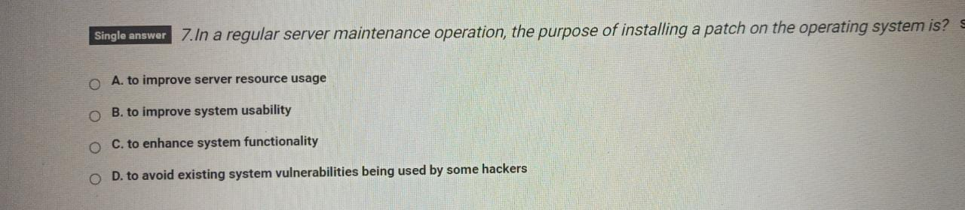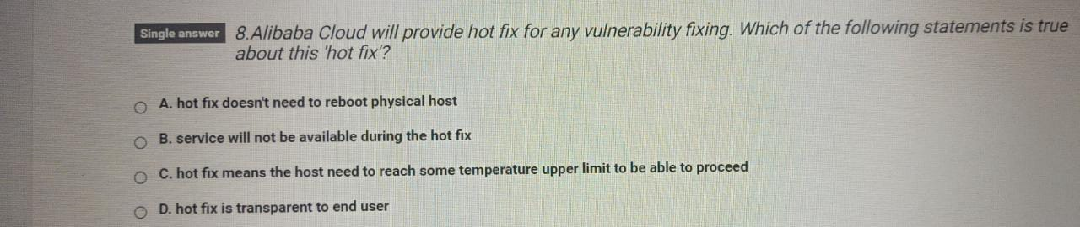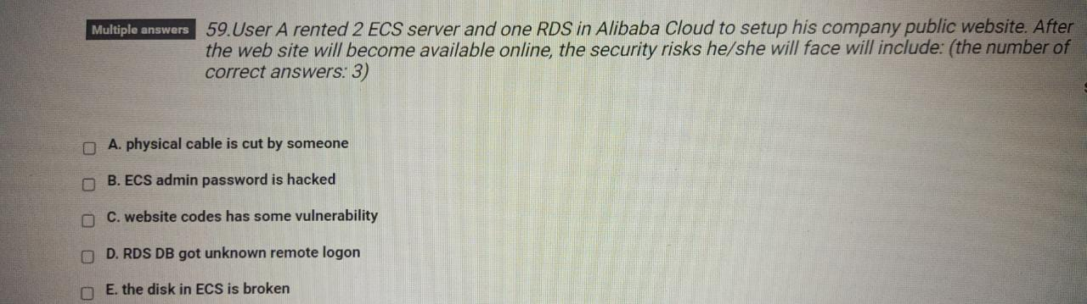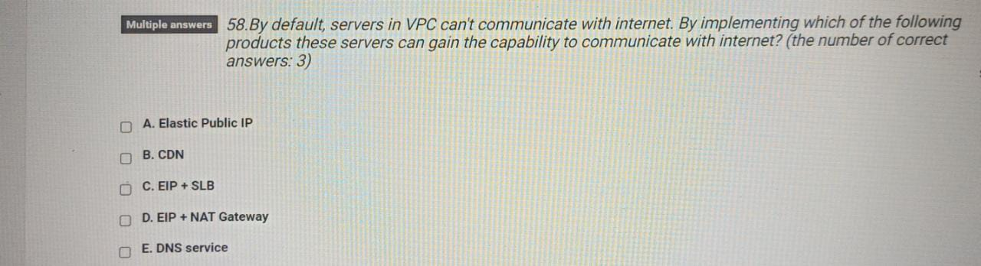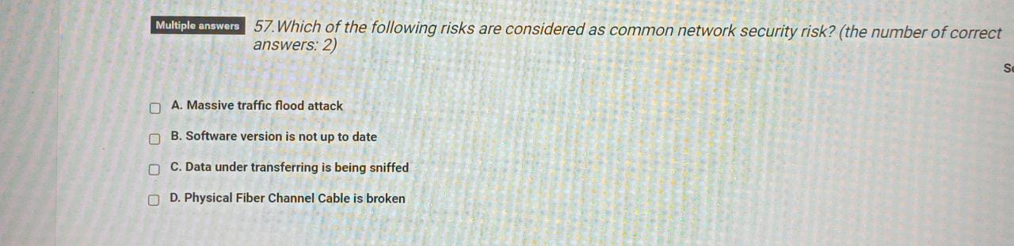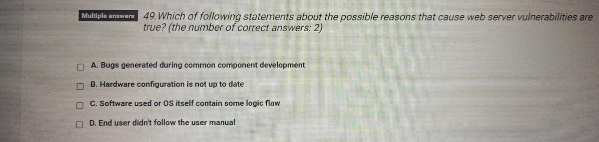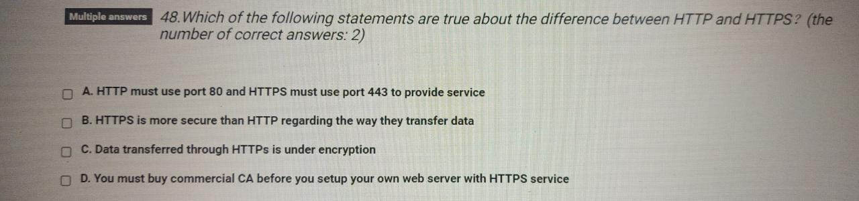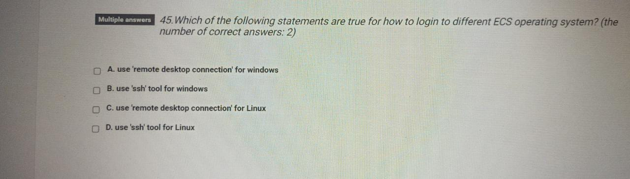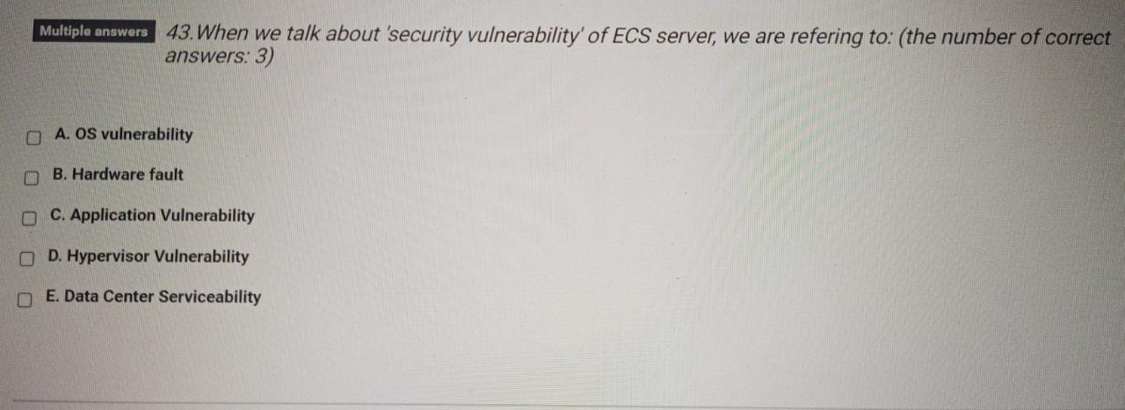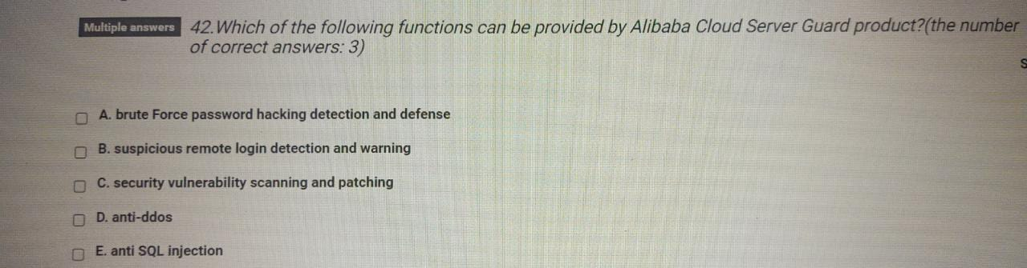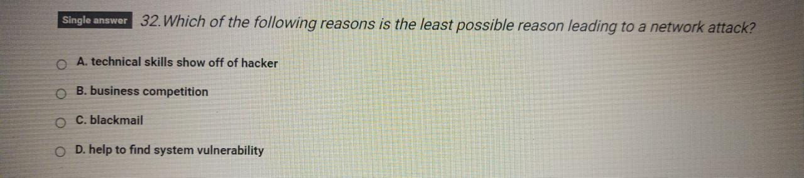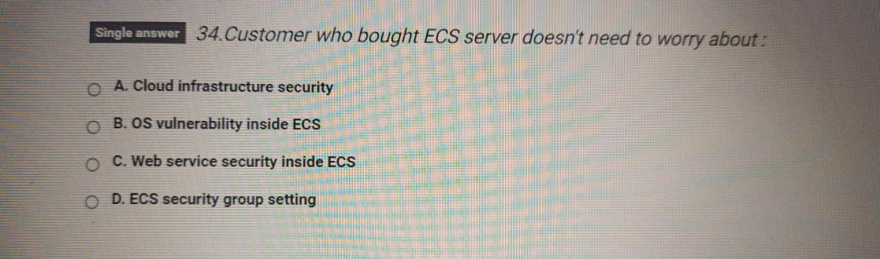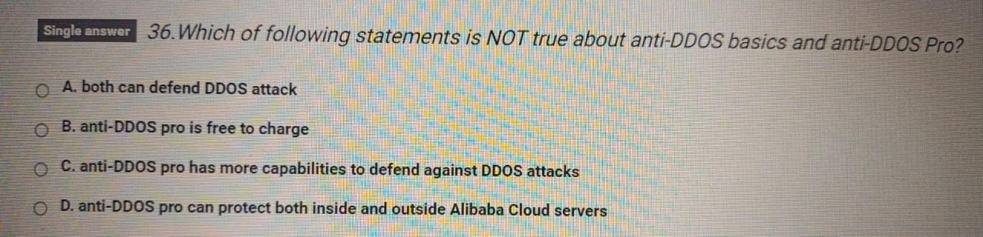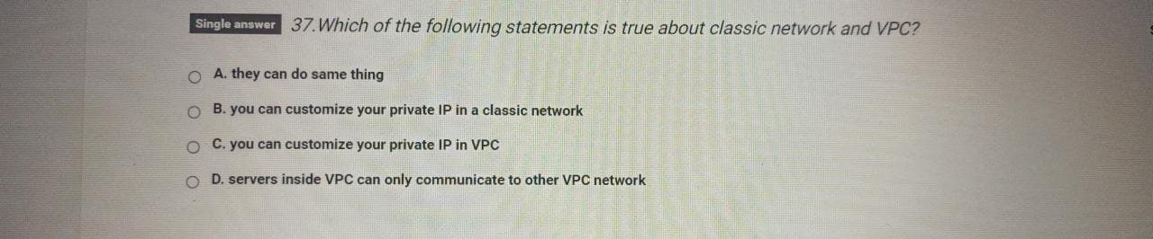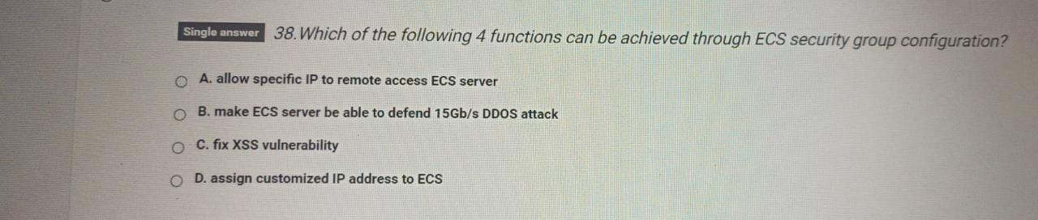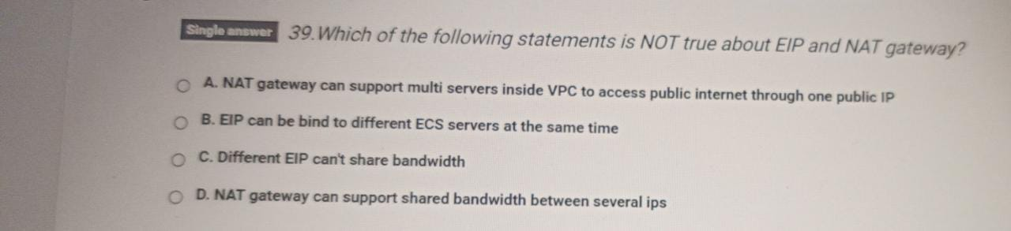

# Kelas

